Waybridge Counseling
Pro Bono Counseling Application
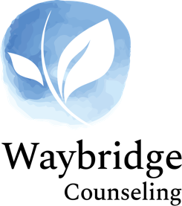

This application is a request for free counseling sessions with one of Waybridge Counseling’s clinicians or clinical interns. If approved, these sessions will expire after an indicated period of time. If further sessions are desired, the applicant can (1) apply for additional free sessions with no guarantee of further pro bono sessions (2) be referred to an intern and pay the intern fee of $75.00 per session for subsequent sessions, (3) or be referred to another clinician and pay the clinician rate.

I am applying for:

Anderson
Blue Ash
Ft Thomas
Scottsdale
Lexington
Dayton
Virtual

About me:
First name:
Last name:
Age:
These sessions are for me.
These sessions are for the following family members:

Contact information:
Phone:
Okay to leave a message?
Email address:
Okay to leave a message?

Address:
Street address:
Address (Line 2):
City, State, Zip:
,
Do you currently have health insurance?
Yes, and the insurance company is:
No

Are you employed?
Yes
No

My presenting concern is:

Other concerns include:

Anxiety
Depression
Postpartum depression
Anger management
Life stress
Domestic violence
Eating disorders
Long-term physical illness
Marital/Partner counseling
Sexual abuse
Physical abuse
PTSD
Sexuality
Gender issues
Grief
Spiritual issues
Loss of employment
Victim of crime
Witness to crime
Family issues
Other, please indicate:

Other information I feel would be important to know about me:

Please send this application to:
butchlosey@waybridgecounseling.com

Waybridge Response to Request:

Approve
Yes # of Sessions for the Approval: Expiration Date:
No Reason for Denial

